***Workshop Safety Precautions***

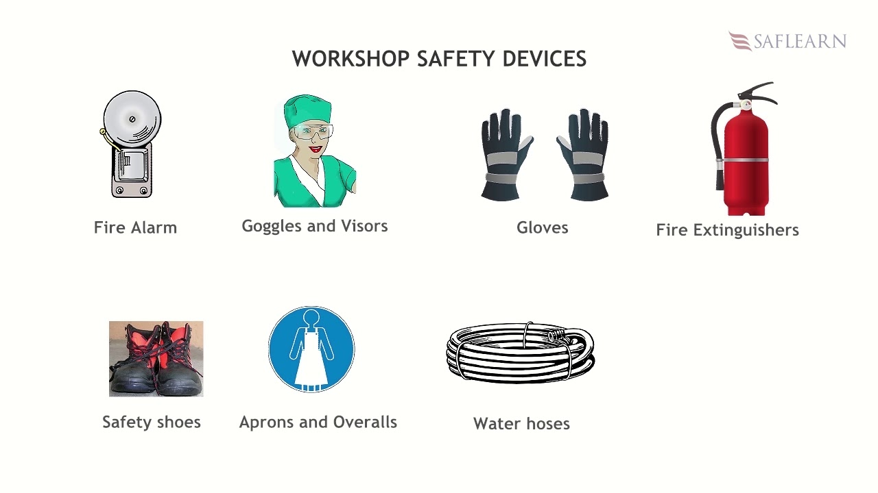

* Wear tight clothes. Loose clothing or long hair will bring danger

*Wear covered footwear. Never use sandals or chapels.

* Never use files, screwdrivers without a handle. Do not use a hammer without the wedge.

* Never operate a machine unless otherwise you thoroughly its mechanism.

*Wear goggles while chipping, welding or grinding

* Always wear safety hand gloves, an apron or dungaree and leather shoes in the Workshop.

* Never touch overhead lines unless you are sure that it is properly earthed and dead.

* Don’t touch /operate power tools without aid from instructors

* Do not throw water on the equipment. It will be harmful since water is a good conductor of electricity.

*Do not touch electrical circuits of welding machine

* Reduce Workplace Stress. ...

*Use Tools and Machines Properly. ...

* Use Mechanical Aids When Possible. ...

* Wear Protective Equipment. ...

* Stay Sober. ...

* Be Aware of Your Surroundings. ...

* Correct Posture Protects Your Back. ...

* Be Alert and Awake

***IMPORTANT OF HOUSEKEEPING***

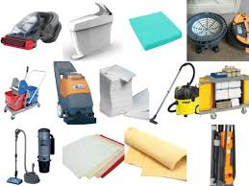

* reduced handling to ease the flow of materials

* fewer tripping and slipping incidents in clutter-free and spill-free work areas

* decreased fire hazards

* lower worker exposures to hazardous products (e.g. dusts, vapours)

* better control of tools and materials, including inventory and supplies

* more efficient equipment clean up and maintenance

* better hygienic conditions leading to improved health

* more effective use of space

* reduced property damage by improving preventive maintenance

* less janitorial work

* improved morale

* improved productivity (tools and materials will be easy to find)

*More effective use of space

*Better inventory control of tools and equipment;

* More efficient clean up and maintenance

*More hygienic workplace conditions and

*Improved look and feel of the work environment